SCIO FIRE DISTRICT
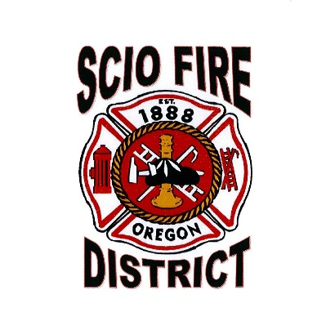
Neighbors Helping Neighbors Since 1888

P.O Box 1 Scio, OR 97374 (503)394-3000

Public Education Request
Last | First | MI

Name:

Phone Number | Email
Contact:

Potential Date of Presentation: _________ Estimated time & Length: ______________ Age Group Range: _____________ Estimated Head Count: _______
Specific Topic of Presentation: ____________________________________________
Location of Presentation: ________________________________________________
Briefly explain what Public Education you would like:

*Before signing, read the disclaimers listed. If you have any questions or would like more information regarding Public Education, contact the Scio Fire District at (503)394-3000, or email chavez@sciofire.org*

Signature: __________________________________ Date: ________________

Disclaimers:

The Scio Fire District is a fully functioning and working Department with 500+ calls per year and responding aide to a District of 101 Square Miles. Due to Staffing shortages or availability, there is a potential for members of the Department to have to respond to 911 calls and leave the presentation. If so, we will reschedule and or offer other services.

Not all requests will be accepted due to other events, presentations, and availabilities. If your request is denied, we will work with you to offer other dates available.

Injuries of any sort will NOT fall upon the Fire District. The adults of the location will be in charge of any and all kids on location during the presentation. The apparatus brought are large and have steps on/into the Fire District Apparatus.

We will ask before hand if we can take pictures throughout the presentation for use of social media, future trainings, and other.

TURNING IN REQUEST:
To turn in your application for Public Education Request, you may email the form to the email below or turn in your application into the main office located at:
38975 SW 6th Ave, Scio OR 97374
EMAIL: Chavez@sciofire.org

